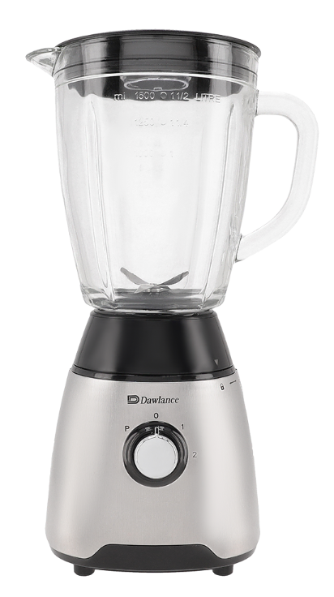

Dawlance Blender
Rs.14,305
Dawlance blender is designed for everyday kitchen mixing, blending, and smoothie preparation with a durable jar, sharp stainless-steel blades, and simple speed control for daily use.

Specifications
- Type: Countertop Blender
- Motor Power: 500 Watts
- Jar Capacity: 1.5 Liters
- Blades: Stainless Steel
- Speed Settings: 2 Speeds + Pulse
- Voltage: 220-240V

Key Features
- Ideal for smoothies, shakes, and sauces
- Strong stainless-steel cutting blades
- Pulse function for better texture control
- Durable jar for everyday family use
- Easy-to-use control knob
- Stable base with anti-slip support

